Creating code comments inVB.NET: Use the **single quote '** key. To comment out multiple lines of code, click the following **button** after highlighting the code.

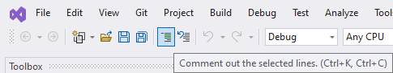

**Part 1**

1. Create a new VB.NET console project.
2. Create four variable doubles named **length**, **width**, **perimeter**, and **area** using an appropriate data type.
3. Prompt the user to provide values for the length and width.
4. Develop code to properly calculate the area and perimeter and store it in the appropriate variables.
5. Display the perimeter and area to the user using meaningful output as seen below. *Note: Your numbers will be different than what is shown below because they will determine on user input.*



**Part 2**

1. Now create a constant named **pi** *without specifying its data type* and set its value to 3.1415926535897932384626433
2. In a code comment, explain what happens to the number in the source code and tell whether the output matches the number in the source code.
3. Create two more constants. One named **pi1** as a double and the other **pi2** as a decimal (the decimal data type was not covered in lecture but will be used for example). Set both of their values to 3.1415926535897932384626433
4. Use **pi1** and **pi2** to calculate the area of a circle whose radius is 6.56 and display the results in output. In a code comment, tell whether or not the same answer is produced and if so, why you think it differs.